**SHEET -2**

1. Create empty files using touch cmd under your home directory

• Xyz1-abc • Xyz2-abc • Xyz3-abc

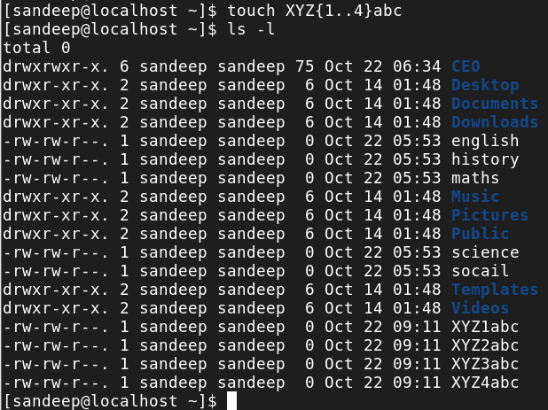

1. Display only these files using ls -l (tip: use wild characters - * or ?)

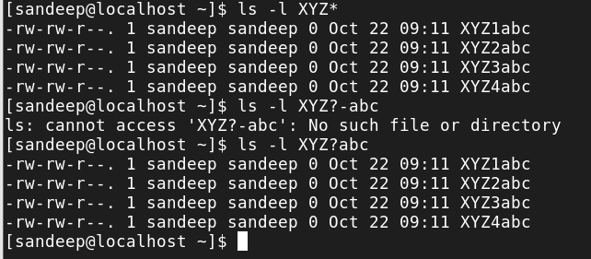

1. Move the files xyz1-abc, xyz2-abc, xyz5-abc to CEO/VP people /HR lead using mv cmd Note: in order to create directory with space use “VP People” or VP\ People

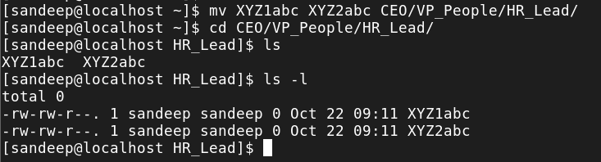

1. Copy the files xyz3-abc …xyz6-abc to CEO/VP Sales/Sales Lead

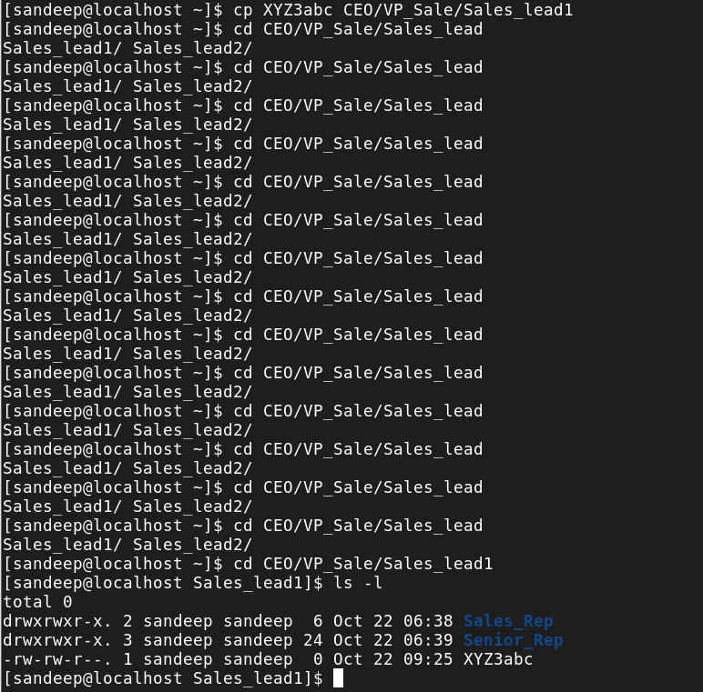

5. Rename the files in ‘HR lead’ to People, Address, Contact

(xyz1-abc as People and so on)

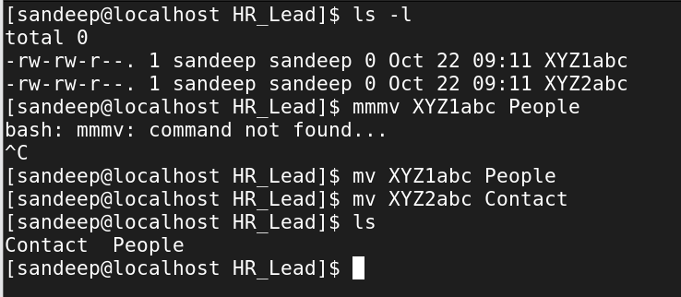

6. From your home directory, Use **find** cmd to find the file People

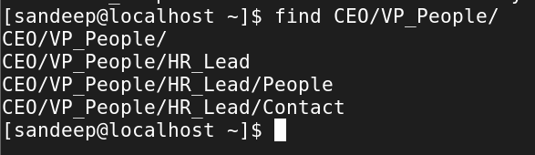

7. Now use **locate** cmd to find the Contact file.

Note: If new files are created, run **updatedb** cmd as root user

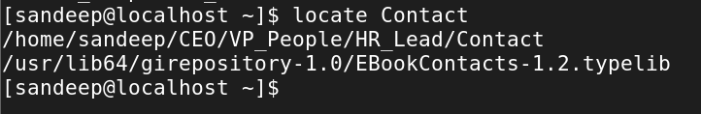

8. Use Echo cmd to display “This is my world !!”

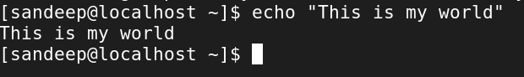

9. Write the output of 8 into the file – People

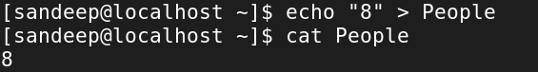

11. Append “My world revolves around Linux” into People.

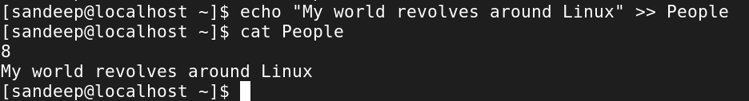

13. Under your user directory, run ls -l cmd and write the output into FileInfo File.

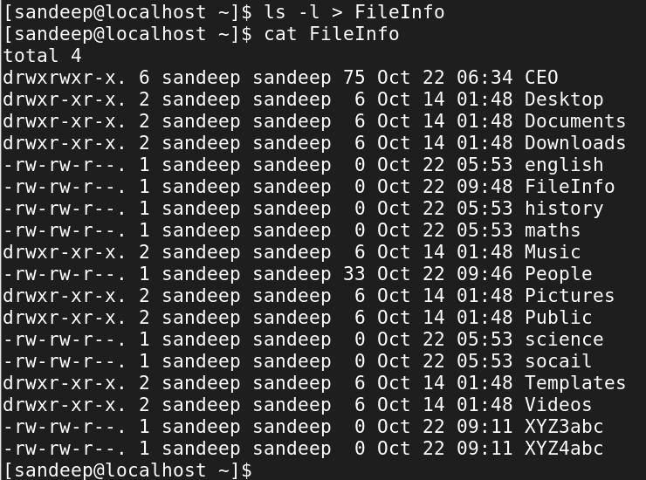

14.Display the contents of the file FileInfo using cat, less, more, head and tail cmd – Observe the difference between the display cmds used

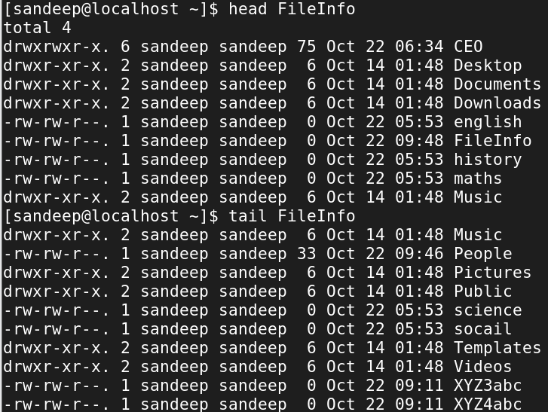

17. Use **history** cmd to get a list of all the cmds used and input that to a file.

